**Upload Instruction**

Please follow the instruction to make sure you input data correctly.

1. Users are expected to have file format to upload MPN Tax data.
2. Users can download file template MPN via add ons screen by selecting the Download Template button.

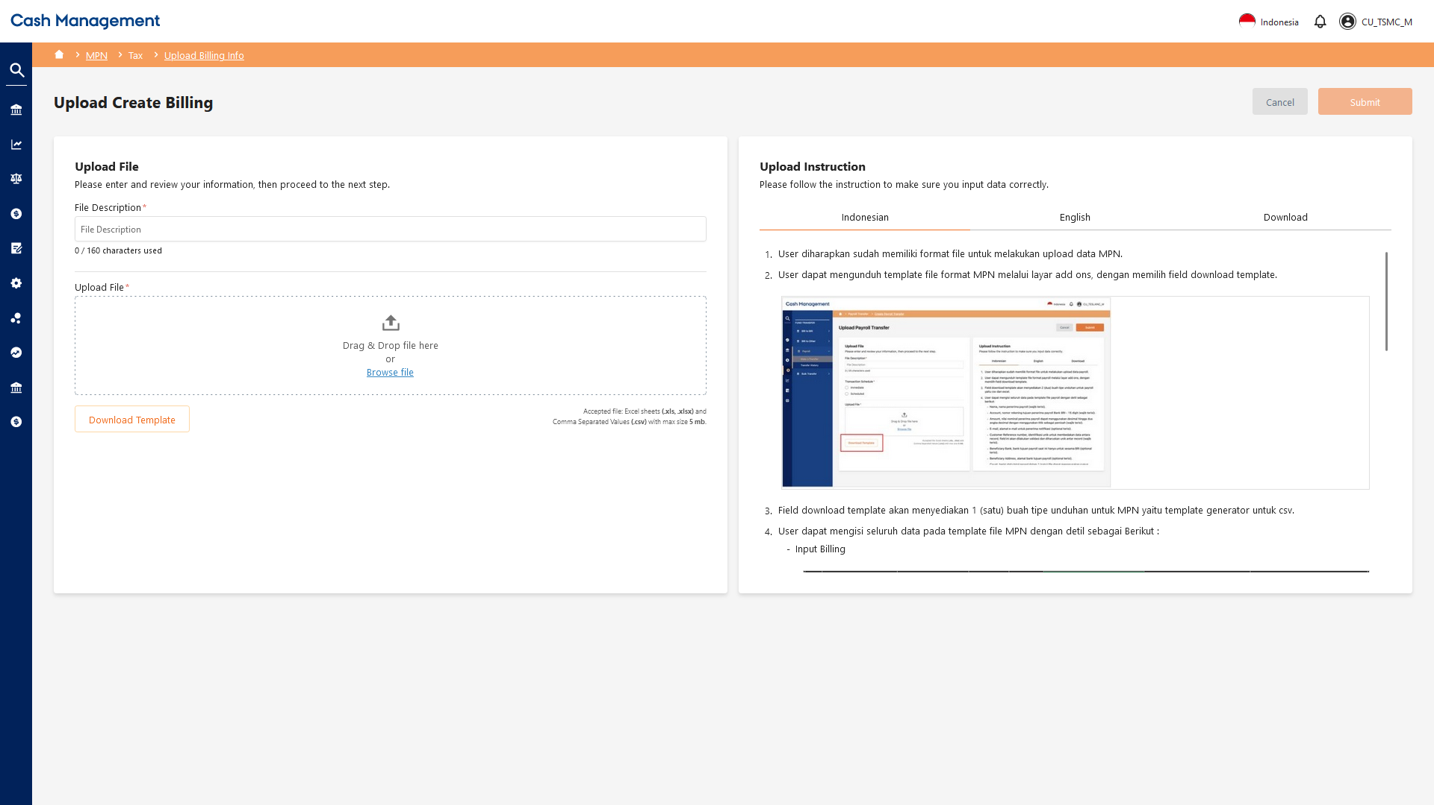

1. Button Download Template provide one template file that can be used to generate csv format or upload excel (xls, xlsx) format
2. Users can fill all the data in the MPN file template with the following details:
   * Input Billing

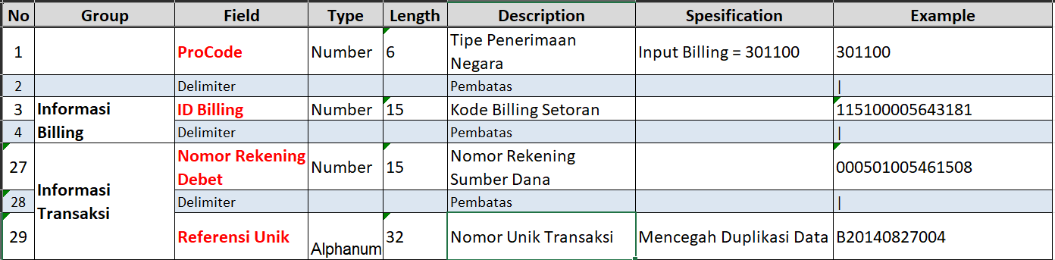

* + Create Billing

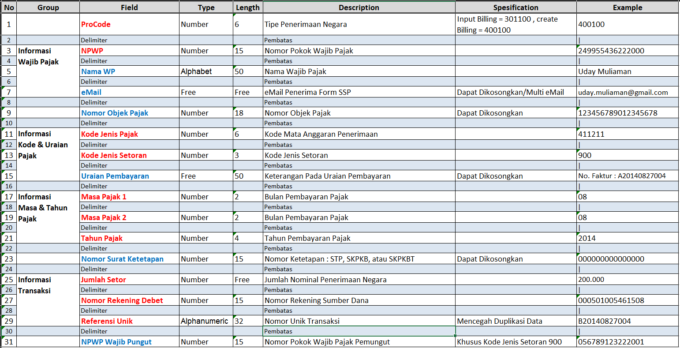

1. Users can fill in data on the MPN file template with maximum of 50.000 record per file or less than 5MB per file (for format csv, xls, and xlsx).
2. Users can perform file conversion if they want to run MPN format file using csv (comma separated value) with delimiter pipe (|).
3. Browse or select the MPN file to run.
4. Click submit to run the MPN and the system will validate the input data.
5. MPN data will be processed in accordance with the approval mechanism that has been formed in workflow management.